Activity No.4
Aim: Connect computer to Router with Ethernet cable.
Theory:
Router:
A router is an electronic device that interconnects two or more computer networks, and selectively interchanges packets of data between them. Each data packet contains address information that a router can use to determine if the source and destination are on the same network, or if the data packet must be transferred from one network to another. Where multiple routers are used in a large collection of interconnected networks, the routers exchange information about target system addresses.
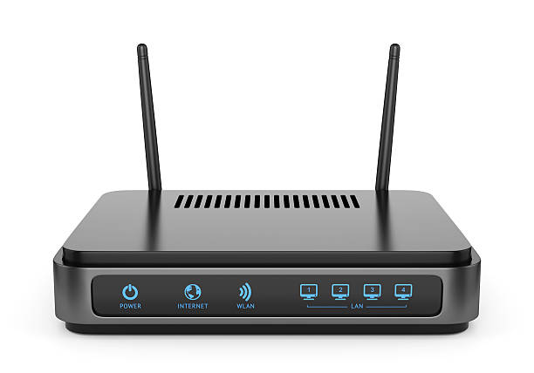
Procedure:
1. Connect to the PC via Ethernet cable with Router.
2. connect the Ethernet cable to the LAN port of the Router.
3.Then connect another part of the Ethernet cable to your Computers LAN port.
4. Start your Computer.
5. Go to Control panel .
6. Now click on Network and Internet.
7. Then click on Network and Sharing center.
8. Then click on Change Adapter setting.
9. Then right click on the internet and click on Enable.
10. If your internet Connection is not turned on.
11. Right click and go to properties.
12.Click the Internet Protocol Versions 4 box.
13.then click ok.

